**Associative & Commutative: (A∧(B∧C)) ⊢ ((A∧B)∧C)** **1**

**Associative & Commutative: (A∨(B∨C)) ⊢ ((A∨B)∨C)** **1**

**De Morgan: (¬A∨¬B) ⊢ ¬(A∧B)** **2**

**De Morgan: ¬(A∨B) ⊢ (¬A∧¬B)** **2**

**Valid: ⊢ (P ∨ ¬P)** **2**

**Valid + (Imp I/E): ⊢ (p→((q→r)→((p→q)→(p→r))))** **3**

**Conditional: (A → B) ⊢ (¬A ∨ B)** **3**

**Conditional: (A ∨ B) ⊢ (¬A → B)** **3**

**Contrapositive: (F → G) ⊢ (¬G → ¬F)** **3**

**Negation: A, ¬¬¬A ⊢ ¬¬¬¬¬¬¬¬A** **4**

**Different Formula 1: ⊢ ((p → (q ∨ ¬r)) → (((q → ¬p) ∧ r) → ¬p)** **4**

# 

| Deduction Strategies |
| --- |
| * ∨ Intr. 를 통한 ⊥ Intr. 가능성 보기 (negate the right side) * assumption 3개까지 일단 ⊥ introduction 해보기 * For all (A → B), think of introducing A as a new assumption for deriving other statements. |

# 

# Associative & Commutative: **(A∧(B∧C)) ⊢ ((A∧B)∧C)**

| **Line #** | **Assumptions** | **Formula** | **Justification** | **References** |
| --- | --- | --- | --- | --- |
| 1 | 1 | (A ∧ (B ∧ C)) | Assumption Introduction | 1 |
| 2 | 1 | A | Conjunction Elimination | 1 |
| 3 | 1 | (B ∧ C) | Conjunction Elimination | 1 |
| 4 | 1 | B | Conjunction Elimination | 3 |
| 5 | 1 | C | Conjunction Elimination | 3 |
| 6 | 1 | (A ∧ B) | Conjunction Introduction | 2, 4 |
| 7 | 1 | ((A ∧ B) ∧ C) | Conjunction Introduction | 6, 5 |

# Associative & Commutative: **(A∨(B∨C)) ⊢ ((A∨B)∨C)**

| **Line #** | **Assumptions** | **Formula** | **Justification** | **References** |
| --- | --- | --- | --- | --- |
| 1 | 1 | (A ∨ (B ∨ C)) | Assumption Introduction |  |
| 2 | 2 | A | Assumption Introduction |  |
| 3 | 3 | (B ∨ C) | Assumption Introduction |  |
| 4 | 2 | (A ∨ B) | Disjunction Introduction | 2 |
| 5 | 2 | ((A ∨ B) ∨ C) | Disjunction Introduction | 4 |
| 6 | 6 | B | Assumption Introduction |  |
| 7 | 7 | C | Assumption Introduction |  |
| 8 | 6 | (A ∨ B) | Disjunction Introduction | 6 |
| 9 | 6 | ((A ∨ B) ∨ C) | Disjunction Introduction | 8 |
| 10 | 7 | ((A ∨ B) ∨ C) | Disjunction Introduction | 7 |
| 11 | 3 | ((A ∨ B) ∨ C) | Disjunction Elimination | 3, 6, 9, 7, 10 |
| 12 | 1 | ((A ∨ B) ∨ C) | Disjunction Elimination | 1, 2, 5, 3, 11 |

# De Morgan: **(¬A∨¬B) ⊢ ¬(A∧B)**

| **Line #** | **Assumptions** | **Formula** | **Justification** | **References** |
| --- | --- | --- | --- | --- |
| 1 | 1 | (¬A ∨ ¬B) | Assumption Introduction |  |
| 2 | 2 | (A ∧ B) | Assumption Introduction |  |
| 3 | 3 | ¬A | Assumption Introduction |  |
| 4 | 4 | ¬B | Assumption Introduction |  |
| 5 | 2 | A | Conjunction Elimination | 2 |
| 6 | 2 | B | Conjunction Elimination | 2 |
| 7 | 2, 3 | ⊥ | Falsum Introduction | 5, 3 |
| 8 | 2, 4 | ⊥ | Falsum Introduction | 6, 4 |
| 9 | 1, 2 | ⊥ | Disjunction Elimination | 1, 3, 7, 4, 8 |
| 10 | 1 | ¬(A ∧ B) | Negation Introduction | 2, 9 |

# De Morgan: **¬(A∨B) ⊢ (¬A∧¬B)**

| **Line #** | **Assumptions** | **Formula** | **Justification** | **References** |
| --- | --- | --- | --- | --- |
| 1 | 1 | ¬(A ∨ B) | Assumption Introduction |  |
| 2 | 2 | A | Assumption Introduction |  |
| 3 | 3 | B | Assumption Introduction |  |
| 4 | 2 | A ∨ B | Disjunction Introduction | 2 |
| 5 | 3 | A ∨ B | Disjunction Introduction | 3 |
| 6 | 1, 2 | ⊥ | Falsum Introduction | 4, 1 |
| 7 | 1, 3 | ⊥ | Falsum Introduction | 5, 1 |
| 8 | 1 | ¬A | Negation Introduction | 2, 6 |
| 9 | 1 | ¬B | Negation Introduction | 3, 7 |
| 10 | 1 | ¬A ∧ ¬B | Conjunction Introduction | 8, 9 |

For ¬(A ∧ B), either A or B has to be known to derive one of ¬A or ¬B.

# Valid: **⊢ (P ∨ ¬P)**

| **Line #** | **Assumptions** | **Formula** | **Justification** | **References** |
| --- | --- | --- | --- | --- |
| 1 | 1 | ¬(P∨¬P) | Assumption Introduction |  |
| 2 | 2 | P | Assumption Introduction |  |
| 3 | 2 | (P ∨ ¬P) | Disjunction Introduction | 2 |
| 4 | 1, 2 | ⊥ | Falsum Introduction | 3, 1 |
| 5 | 1 | ¬P | Negation Introduction | 2, 4 |
| 6 | 1 | (P ∨ ¬P) | Disjunction Introduction | 5 |
| 7 | 1 | ⊥ | Falsum Introduction | 6, 1 |
| 8 |  | (P ∨ ¬P) | Negation Elimination | 1, 7 |

# Valid + (Imp I/E): **⊢ (p→((q→r)→((p→q)→(p→r))))**

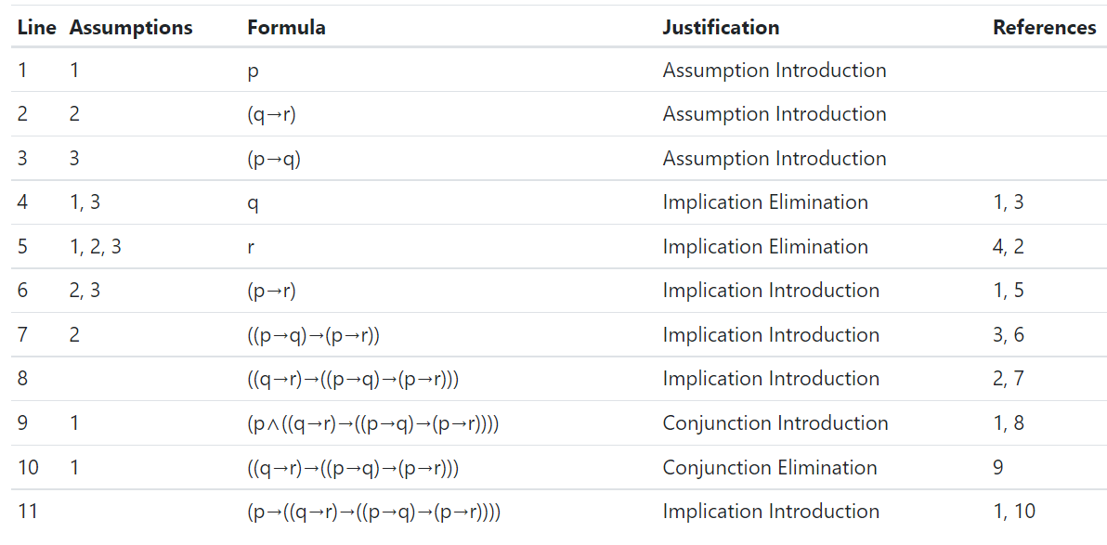

# Conditional: **(A → B) ⊢ (¬A ∨ B)**

| **Line #** | **Assumptions** | **Formula** | **Justification** | **References** |
| --- | --- | --- | --- | --- |
| 1 | 1 | (A → B) | Assumption Introduction |  |
| 2 | 2 | A | Assumption Introduction |  |
| 3 | 1, 2 | B | Implication Elimination | 2, 1 |
| 4 | 4 | ¬(¬A ∨ B) | Assumption Introduction |  |
| 5 | 1, 2 | (¬A ∨ B) | Disjunction Introduction | 3 |
| 6 | 1, 2, 4 | ⊥ | Falsum Introduction | 5, 4 |
| 7 | 1, 4 | ¬A | Negation Introduction | 2, 6 |
| 8 | 1, 4 | (¬A ∨ B) | Disjunction Introduction | 7 |
| 9 | 1, 4 | ⊥ | Falsum Introduction | 8, 4 |
| 10 | 1 | (¬A ∨ B) | Negation Elimination | 4, 9 |

# Conditional: **(A ∨ B) ⊢ (¬A → B)**

| **Line #** | **Assumptions** | **Formula** | **Justification** | **References** |
| --- | --- | --- | --- | --- |
| 1 | 1 | (A ∨ B) | Assumption Introduction |  |
| 2 | 2 | A | Assumption Introduction |  |
| 3 | 3 | B | Assumption Introduction |  |
| 4 | 4 | ¬A | Assumption Introduction |  |
| 5 | 2, 4 | ⊥ | Falsum Introduction | 2, 4 |
| 6 | 2, 4 | B | Falsum Elimination | 5 |
| 7 | 1, 4 | B | Disjunction Elimination | 1, 2, 6, 3, 3 |
| 8 | 1 | ¬A → B | Implication Introduction | 4, 7 |

# Contrapositive: (F → G) ⊢ (¬G → ¬F)

| **Line #** | **Assumptions** | **Formula** | **Justification** | **References** |
| --- | --- | --- | --- | --- |
| 1 | 1 | F → G | Assumption Introduction |  |
| 2 | 2 | ¬G | Assumption Introduction |  |
| 3 | 3 | F | Assumption Introduction |  |
| 4 | 1, 3 | G | Implication Elimination | 3, 1 |
| 5 | 1, 2, 3 | ⊥ | Falsum Introduction | 4, 2 |
| 6 | 1, 2 | ¬F | Negation Introduction | 3, 5 |
| 7 | 1 | ¬G → ¬F | Implication Introduction | 2, 6 |

# Negation: **A, ¬¬¬A ⊢ ¬¬¬¬¬¬¬¬A**

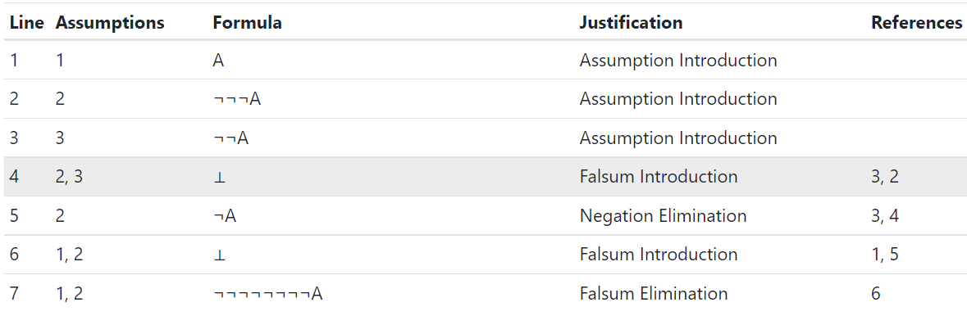

# Different Formula 1: **⊢ ((p → (q ∨ ¬r)) → (((q → ¬p) ∧ r) → ¬p)**

